Sometimes a payroll is run on a computer that does not have the Employee E-Mail Suite product installed. When this occurs that payroll does not appear in the upper list on the E-mail Earnings Statements form as seen below.

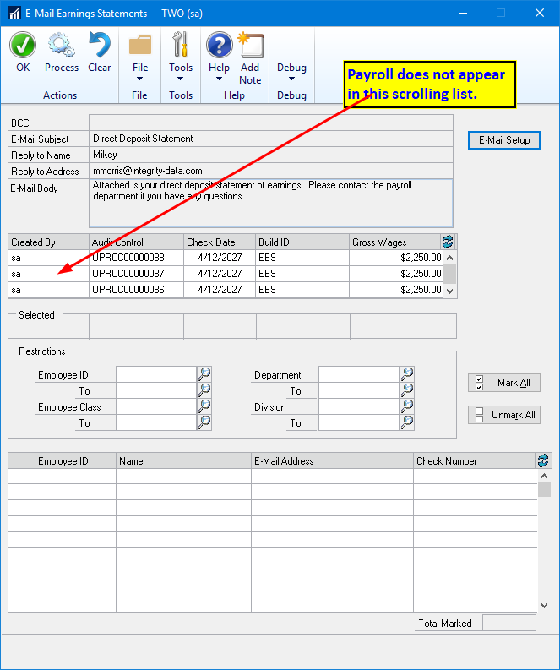

To bring the payroll into the list go to the Create Email Earnings History form.

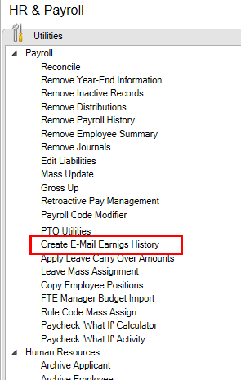

Find the Audit Control Number of the missing payroll and check the box on the left of the row to select it. Then click Process and wait for the process to complete.

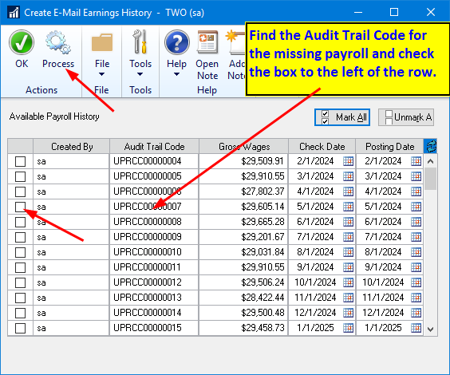

Once the process completes close the form and go the Email Earnings Statements form and the payroll should now appear in the upper scrolling region and you can select it and continue as normal.

